Power BI-Dashboard Visualizations::

**PowerBI Dashboard**

A PowerBI dashboard is a single page that contains a **collection of visuals**built for a deep level of interactivity. In simple words, It is a page with multiple charts and graphs that help to derive useful information from a number of data.

**Advantages of PowerBI Dashboards**

* Embedded Attributes
* Rich Features
* Easy Implementation
* Drag and Drop
* No Upfront class
* Allows Collaboration
* Continuous Updates
* Publish reports Securely

**Power BI Dashboards vs Reports**

|  |  |
| --- | --- |
| **Dashboards** | **Reports** |
| The dashboard is an effective business data view from where navigation to reports originates. | Reports are built based on datasets where each dataset can be viewed from different points of view. |
| It is a single page that displays the summary of the whole data. | You can create a Multi page in a single Report. |
| The dashboard is allowed only in Power BI Service. | The report is allowed in both Desktop & Power BI Services. |
| One or more datasets/reports can able to use per dashboard. | A single dataset is used per report. |
| Email Data Alerts are possible. | Email Data alerts are not possible. |
| It supports only Bookmarks. | Report support many filter options like Bookmarks, Filters & Slicers. |

**Which is more Effective?**

Promptly, you can’t separate Power BI dashboards and reports. They’re the North and South of Microsoft’s business intelligence: they organize each other. Both are high-powered, flexible, and booming tools that can give a comprehensive wider picture or a comprehensive look at the minutiae and finer details

As a whole, A good IT manager or business user can best leverage the tools at their disposal according to the needs and demands of the situation. So, Both **Dashboards and Reports** are Effective in their own way.

**How to Create a Simple Dashboard?**

**Step 1: Importing data.**

**Dataset used here: https://www.kaggle.com/datasets/rhuebner/human-resources-data-set**

The first step after opening the Power BI application is to gain access to your data. You can easily import your dataset from any format. Then click on the **Get Data** button located at the middle left corner of the screen.

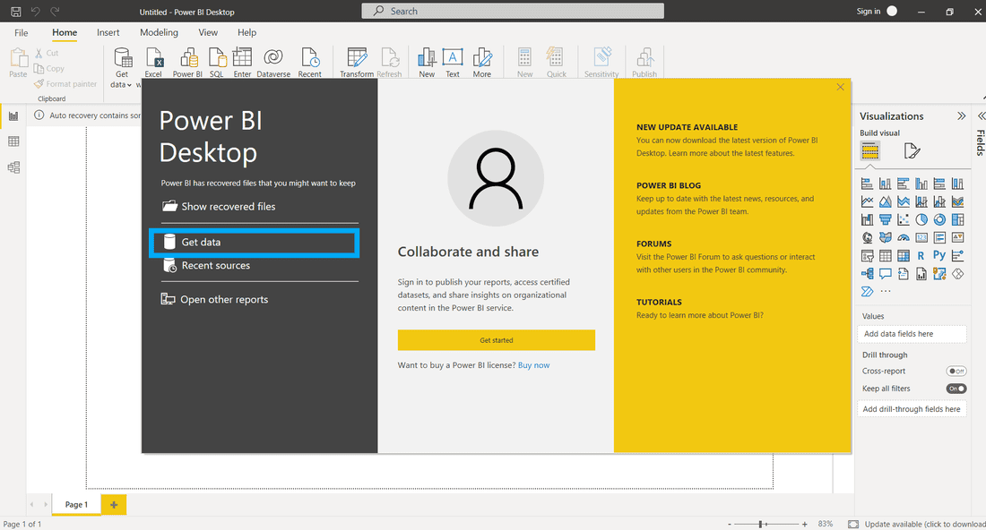

The navigation pane shows the option of Files. Click on Files and browse to the location where your Excel Workbook or any other format is located. Choose your file and then click on the **Connect** button.

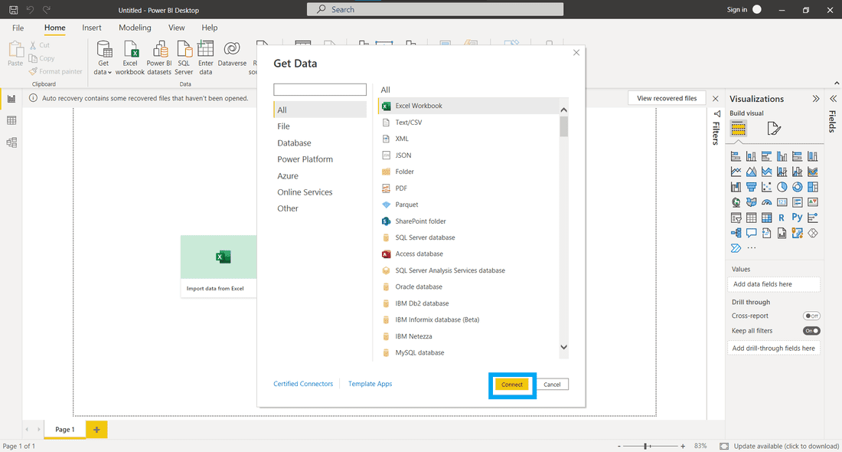

It takes a little time to process which depends on the file size. Make sure the data is extracted and load the data by clicking the **Load** button.

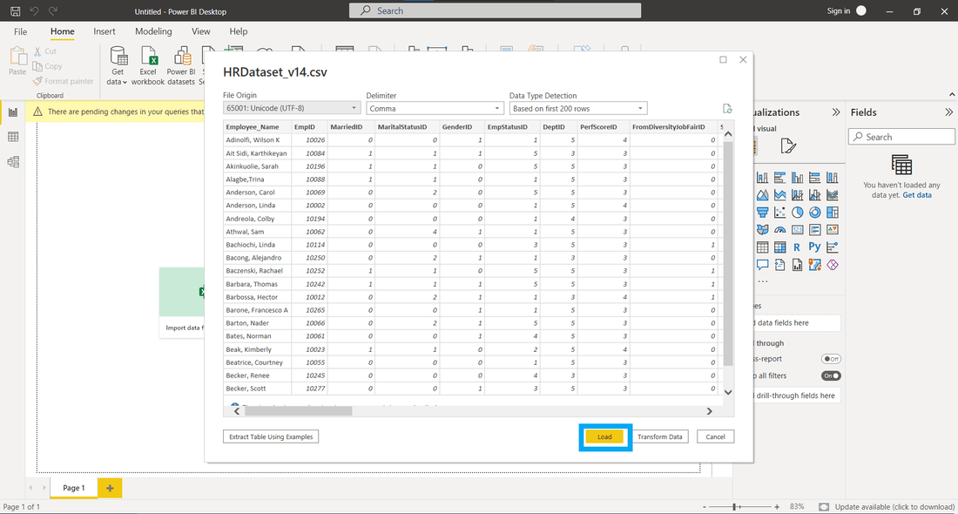

**Step 2: Explore Your Data.**

From the **Data** tab, you can view the tabular form of data. On the right, you’ll find a list of fields within those tables.

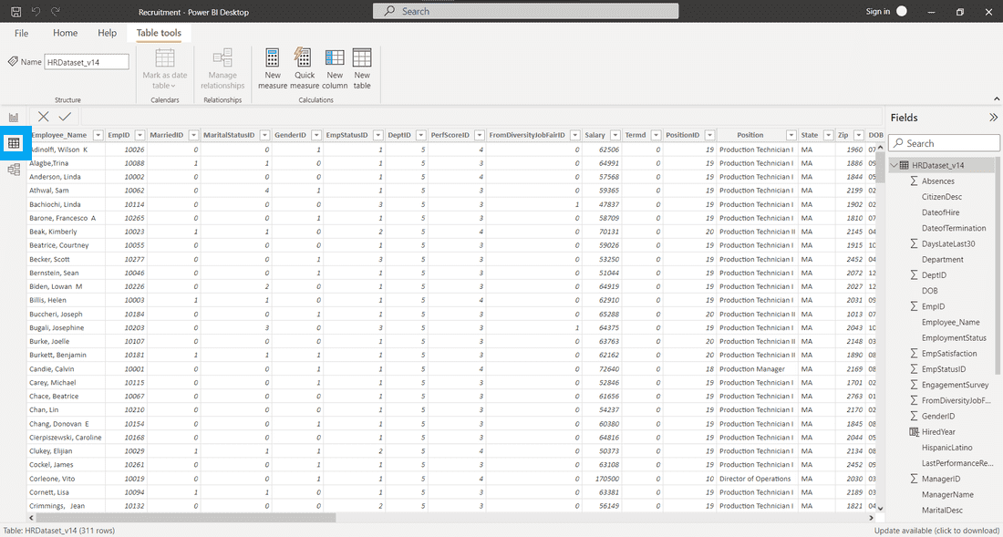

You can select a table or field to perform formatting actions on them. If you have fields such as date, time, city, state, percentage value, currency, etc. you can change the datatype or format from the**Modeling** tab.

**Step 3: Choose the Right Chart.**

So, for our dashboard, we decided to work on five fields: Hiredyear, RecruitmentSource, Position, EmployerId, and male-female employment. The first visualization that we’ll make is a Card. Select **Card** from the visualizations section.

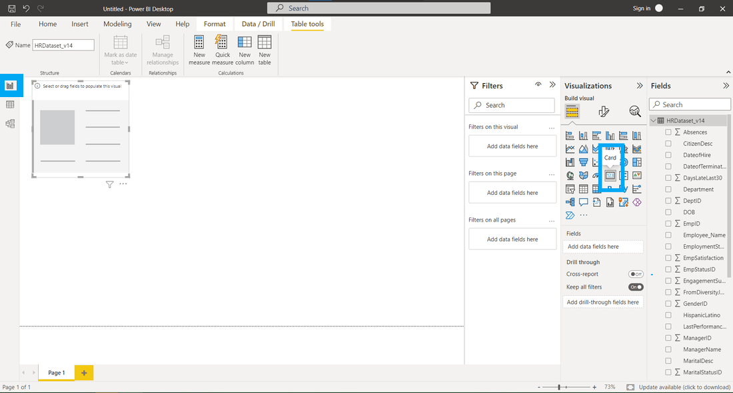

Select the columns you want to add to the visual from the **Fields** section. You can also drag and drop the fields into respective columns indicated by the image below.

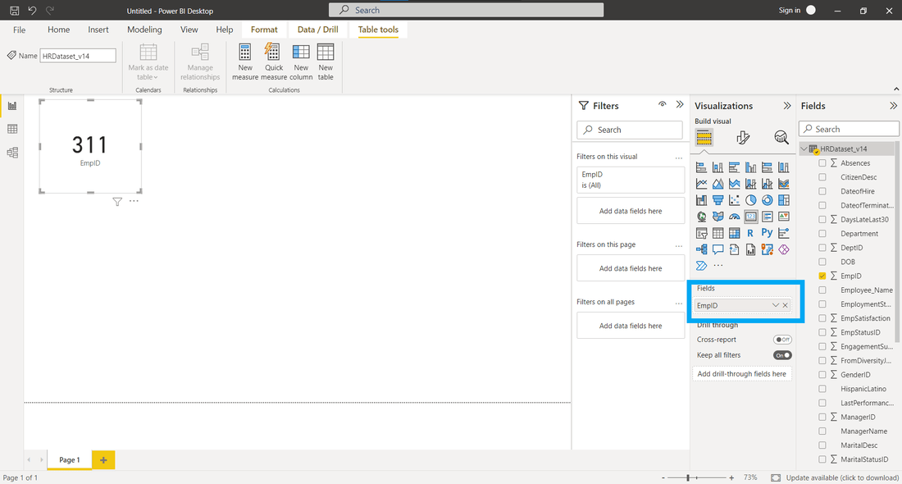

You can select columns, apply filters, and format the visual from the Format icon. The first card we prepared shows the Total number of Employers.

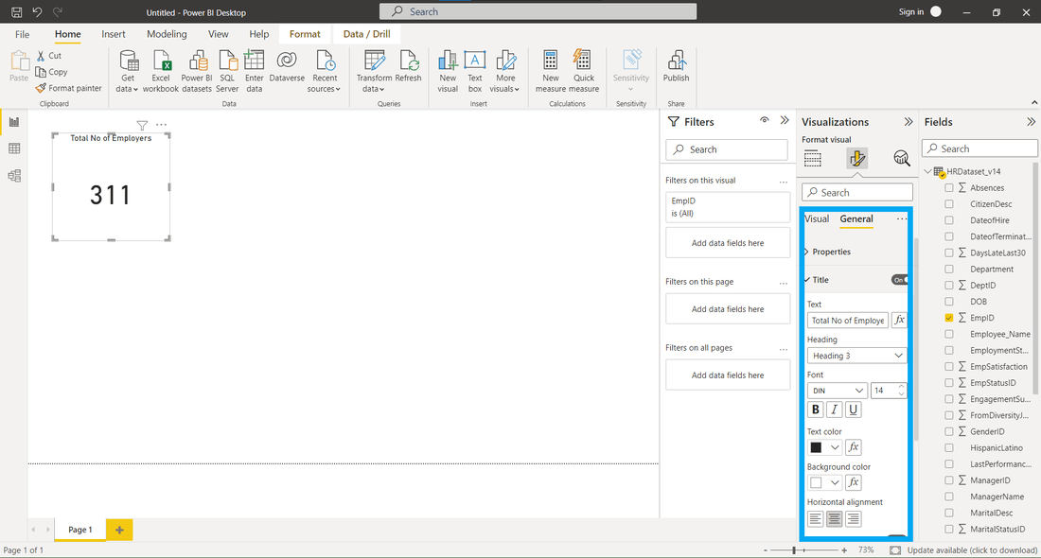

The Same procedures were followed for the remaining cards. The second, third, and fourth cards show the Number of Recruitment Sources, Positions, and Maximum Salary respectively.

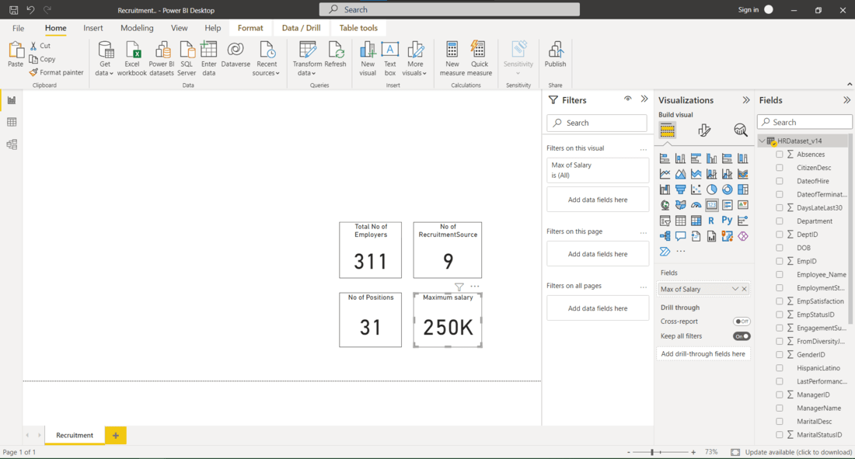

Next, we’ll create a Pie Chart and a Donut chart which is going to show the Count of positions and Male – female rate respectively. Add this chart from the Visualizations.

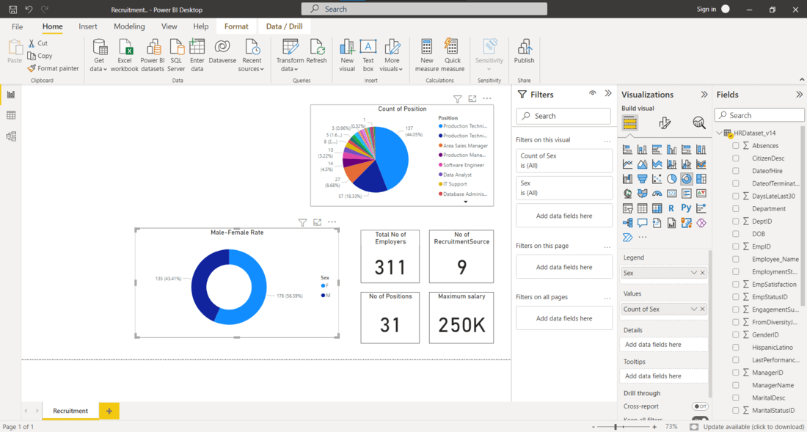

Finally, add Funnel and Stacked Bar Chart to show the Number of Hired yearly and Recruitment source proportionally. Format the title, data labels, legend, axes, plot area, data colors, etc. As you can see in the below image.

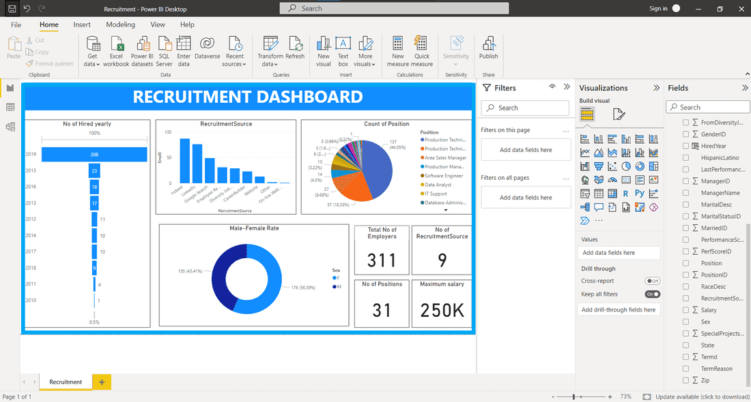

**Power BI – Dashboard Actions**

A single page, or palette, is what is referred to as a Power BI dashboard and it employs visualizations to convey a story. As it can only fit on one page, a well-designed dashboard delivers only the essentials of the scenario. Dashboards are a feature of the Power BI service. When utilizing Power BI Desktop, they are not available. Mobile devices can be used to view and publish dashboards but not to create them.

The dashboard’s visuals are referred to as tiles. Every report is based on a dataset, and you can pin tiles from those reports to a dashboard. A dashboard serves as an introduction to the reports and datasets that it displays. You can access the report and dataset that the selected visualization is based on by selecting it.

**Power BI Dashboards**

Let’s create a Super Store Sales Report and pin it to the dashboard, to explore the Dashboard actions. Dataset Used: [Superstore Orders](https://docs.google.com/spreadsheets/d/1eJLnPB0edhnEoIAHKiAh2ppQTuvX5psW/edit?usp=sharing&ouid=116017789196340894867&rtpof=true&sd=true).

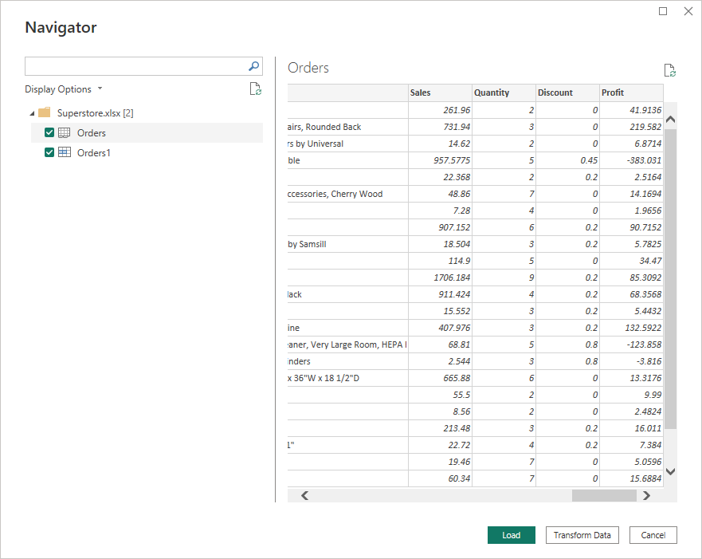

Here we have created four visuals viz. Donut charts based on Profit by Region and Profit by Category, a Horizontal Bar Chart of Profit by Sub-category, and a line chart of Profit by Order Date, into which we have a Drill-up to view Profit by Quarter visual.

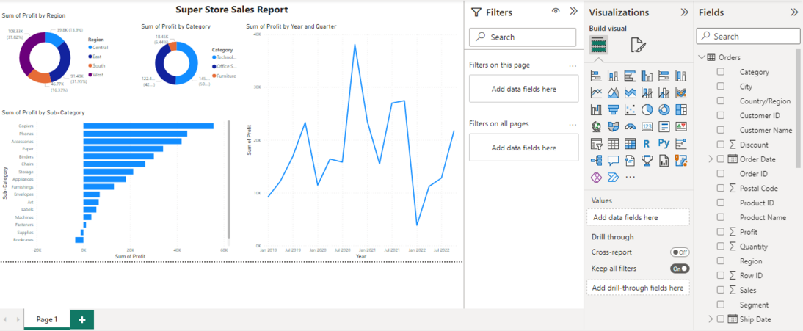

And then Publish the Report.

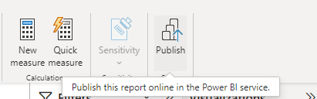

**How to Create a Dashboard?**

A dashboard can be made in a variety of ways. You can build a dashboard, for instance, from scratch, from a dataset, a report, or by copying an existing dashboard.

* To open a report in the editing view, open it and choose More options (…) > Edit.

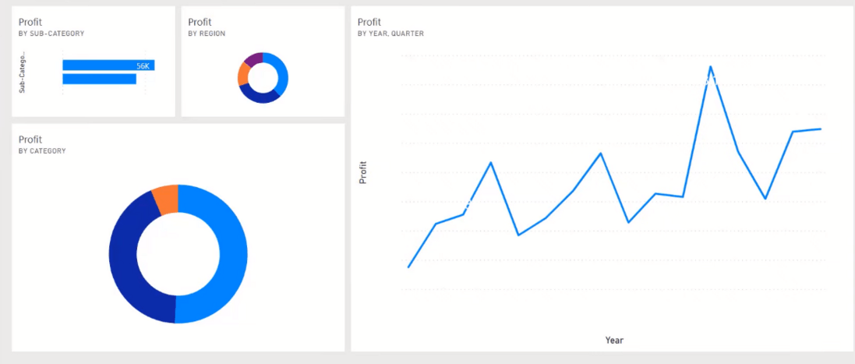

* Hover over a visualization to reveal the options that are available. To add a visualization to a dashboard, select the pin icon. Select whether to pin to an existing dashboard or a new dashboard.

In this instance, we choose the New dashboard option and type in a name.

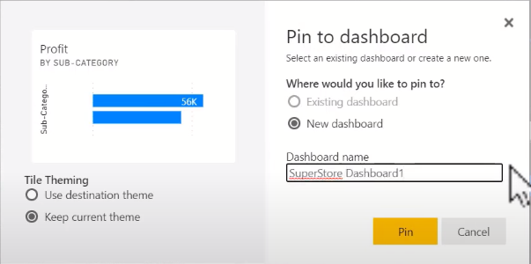

**New dashboard:** Type the new dashboard’s name here, and Pin the visualization.

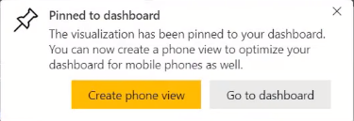

As we can see, below is the dashboard status,

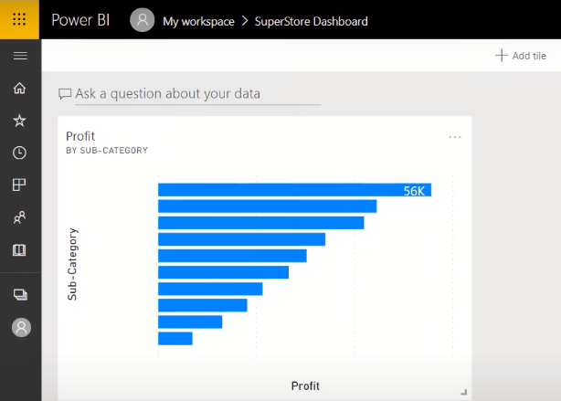

**Existing dashboard:** From the selection, choose the dashboard’s name. Dashboards that you have been given access to will not show up in the dropdown.

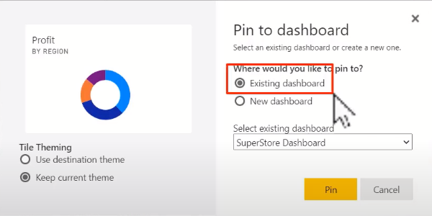

The object you’re pinning might already have a theme applied in some circumstances. images pinned from an Excel spreadsheet, as an illustration. If so, decide the theme to use when applying the tile:

***Use destination theme:****The dashboard’s design.*

***Keep current theme:****The report’s key idea.*

* Power BI produces a new dashboard in the active workspace when you choose Pin.

In this way, we can create the Super Store Sales Report Dashboard.

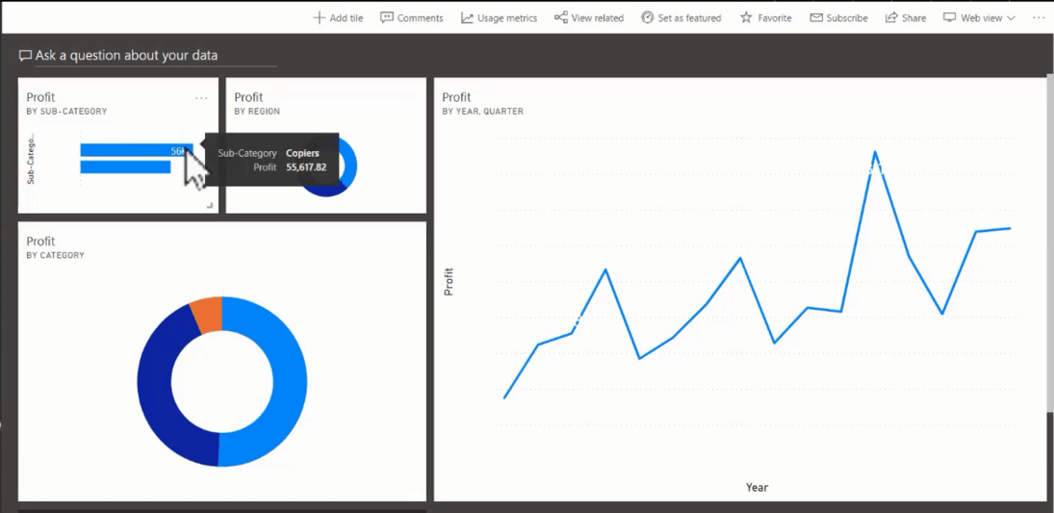

A user’s workspaces are displayed when they connect to the Power BI Service. “My Workspaces” is frequently utilized as a private “scratch patch” for individual projects.

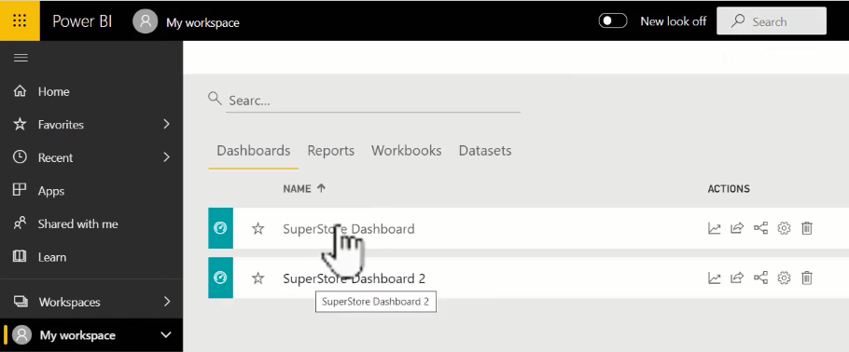

The “Workspaces” section allows users to establish as many workspaces as they need, each one dedicated to a different project or area. This will also display any workspaces that the user has access to. Each workspace consists of the following five divisions:

* **Reports:** Reports are made up of numerous graphics (tables, graphs, etc.) created from a single dataset.
* **Dashboards:** Multiple visualizations (graphs, tables, etc.) from one or more reports—each of which was created using a single dataset—make up dashboards.
* **Workbooks:**The Power BI service accepts uploads of unformatted Excel workbooks.
* **Datasets:** A dataset is a group of data that you import or connect to. A dataset can be shared among numerous users and used in one or more workspaces.

Elements-of-Workspace

**Dataflows:**Organizations can mix data from many data sources with the aid of dataflows. Dataflows are optional but are frequently employed in more difficult or substantial projects. They stand for prepared and staged data that datasets can use. They can’t be utilized as a direct source for reporting, though.

* Select Go to dashboard when the Pinned to Dashboard notification appears. If asked to save the report, choose Save.
* The visualization you just pinned is the only tile on the new dashboard that Power BI opens.
* To go back to the report, select the tile. More tiles should be pinned to the new dashboard. Choose Existing dashboard when the Pin to dashboard window displays.

When you pin graphics to a dashboard, some report formatting settings or themes aren’t applied to them.

**Benefits of Dashboard**

It offers a means to keep a close watch on your company and see all of your key KPIs at a glance. A dashboard’s visualizations may be drawn from a single underlying dataset or several, as well as from a single underlying report or several. A dashboard provides a consolidated view of data by fusing data from on-premises and the cloud. The dashboard is more than simply a lovely image. The tiles update when the underlying data changes, and it is very interactive.

A report’s edit rights are necessary in order to be able to create a dashboard, which is regarded as a creator feature. Report creators and co-workers who have been given access by the creator can edit reports.

**Difference between Dashboard and Reports**

| **Features** | **Report** | **Dashboard** |
| --- | --- | --- |
| **Pages** | One or more pages | One page |
| **Data Sources** | A single dataset per report | One or more reports and one or more datasets per dashboard can be a Report, Different dashboard, Excel sheet, image, videos, etc. |
| **Drill Up ad Drill Down Filters** | Yes. There are numerous methods for filtering, highlighting, and slicing data. | No. A dashboard cannot be cut or filtered. In focus mode, a dashboard tile can be filtered, however, the filter cannot be saved. |
| **Accessible in Power BI Desktop** | Yes. You can build and view reports in Power BI Desktop. | No |
| **See underlying dataset tables and fields** | Yes | No. Tables and fields are hidden in the dashboard itself, however, data can be exported. |

**Confinements of a Dashboard**

* The pinned tile disregards the settings for the border, shadow, and background.
* Dashboards for card visuals use the ‘DIN’ font family and black lettering to display the text used for the value. By designing a unique dashboard theme, you can alter the text color for each tile on the dashboard.
* There is no conditional formatting used.
* The size of the visuals will change to meet the size of the tile. This may lead to layout variations that appear as though the report’s visual had been resized.
* Pinning might not function if the backdrop image is too large because certain visualizations use them as backgrounds. Consider utilizing image compression or lowering the image size.

**Dashboard Actions**

In the Power BI service, you can keep track of who is using your reports. I’ll demonstrate how simple it is to locate and create this report utilizing the power bi service, as well as how to connect, obtain this data on your own, and adapt it for your own needs.

**View Usage Metrics Report of a Power BI Dashboard**

This feature enables you to access a Power BI dashboard’s traffic data in report format. Let’s use analyzing sales reports as an example.

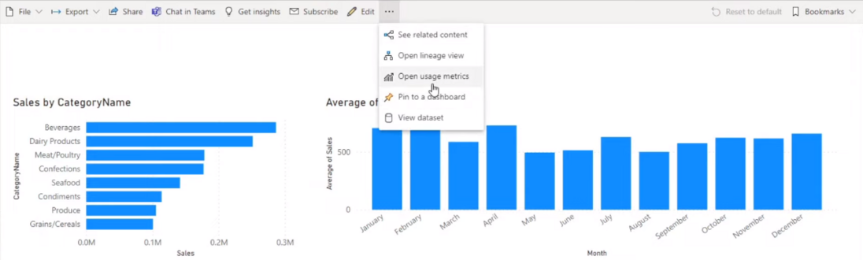

This is a very straightforward report that does nothing more than analyze sales for a hypothetical company. If you want to find out how many users actually access this report, all you have to do is click more options and select usage metrics. If you’ve never opened usage metrics for a report before, this will generate first, but once it does, it will take you to the page shown below:

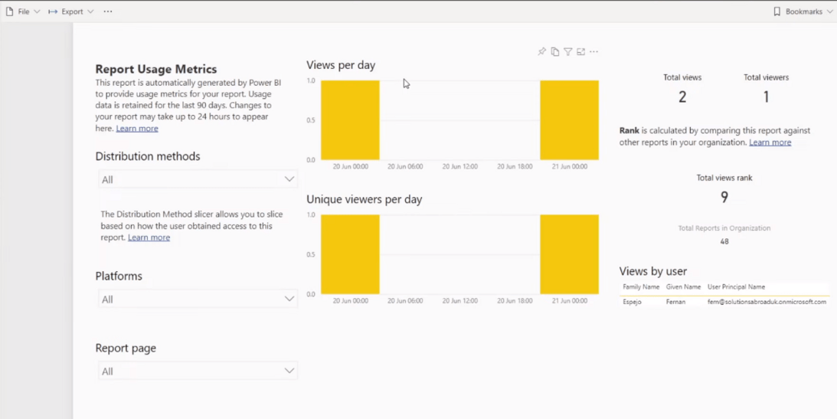

As a result, you’ll notice that this report’s design and layout are familiar because it is essentially an internal Power BI report that provides you with some useful information, such as the number of views your reports receive each day, the demographics of the viewers, and whether they access your reports via mobile or desktop. You can even view distribution channels or frequently utilized report pages.

**Share Power BI Dashboard**

To distribute this dashboard around the company, use this feature.

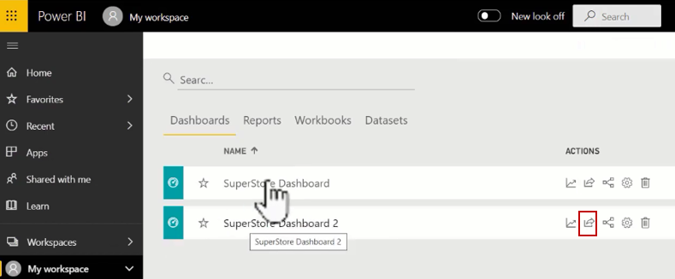

Open the report from Dashboard and select “Share”.

share

When working with power bi reports, sharing them within the service would typically require at least a pro license, not just for you who is sharing the report but also for the people with that you are sharing the reports. This means that if you or your organization does not already have power bi licenses, building and publishing reports is simple, but sharing them within the organization can be a little bit challenging.

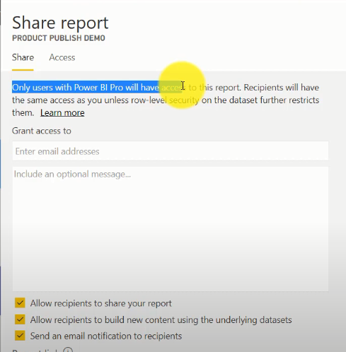

The simplest way to share a report with your team is to take a screenshot of it. You can do this with any snipping tool, like this one from Windows, by simply dragging and selecting the page you want to capture. The image you create is essentially a static version of your report, but it makes it simple to save and send to your coworkers. The next method is to export your report to PowerPoint.

**View Related Items of a Power BI Dashboard**

You can use this feature to see the items that are connected to the dashboard that we utilized to develop it. Click on the below-shown icon and view the related items.

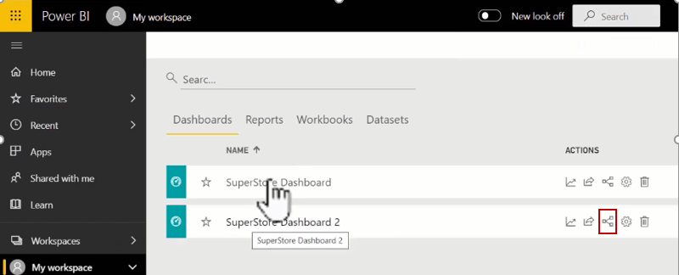

**Power BI Dashboard Settings**

You can change the Power BI dashboard settings like Dashboard Name, Q&A, Dashboard tile flow, etc. by using this option.

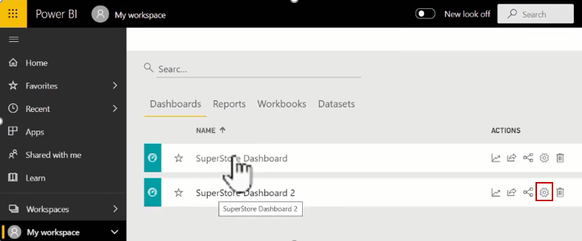

Select the gear icon you will see settings that you can do for example if you don’t if you want to hide the visual header or if you don’t want the end user to save the filter on this report then you can enable this and so that the end user will not be able to save their filters.

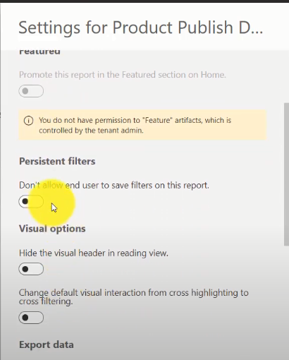

**Delete Power BI Dashboard**

This feature lets you delete the not-in-need Power BI dashboard from the workspace.

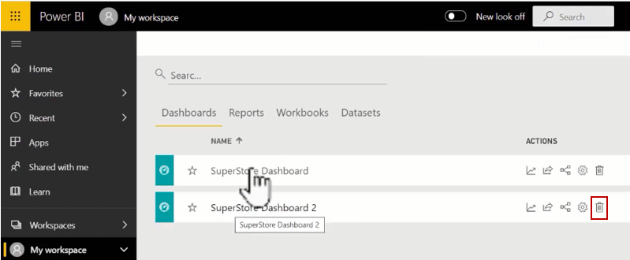

**What are Stacked Charts & Bar Charts?**

Stacked charts are a sort of bar chart which are multiple-series in nature where related values are placed atop one another. This feature allows comparing the contribution of worth to a total, either in absolute or percentage terms, and comparing multiple categories and category totals simultaneously.

Bar Charts are a summary of categorical data and display data using several bars, each representing a particular category. The height of each bar is equal to the sum of the values in the category it represents. It is also possible to color or split each bar into another categorical row in the data, which enables you to see the contribution from different categories to each bar or group of bars in the bar chart.

**Types Of Bar Charts**

 There are mainly two variations of Bar Chats. Depending on the situation charts are used.

* Clustered Bar Charts: This is a default Bar chart where all the categories are displayed against the same value category.
* Stacked Bar Charts: These are the basic typed charts that allow the comparison of one category to another category.

**Main Parts of Stacked Bar Charts**

* Title: It denotes the information about the chart
* X-axis: It is the individual entry for the category to be presented
* Legend:  It is the different category that will contribute to the charts
* Y-axis: It is for the value against each type of category
* Bars: These heights represent the total value of all the legend

**Creation of Stacked Bar Charts**

Import data from Your Excel to Power BI. To develop this tutorial we have used this [dataset](https://docs.google.com/spreadsheets/d/12icOE6BZShrWuTTnYpIsZM7JX17WY3G4/edit?usp=share_link&ouid=111625194693410552784&rtpof=true&sd=true).

Home Tab-> Get Data -> Choose Data which you want Example Excel ->

Select the file and Open -> Select The sheet and Load

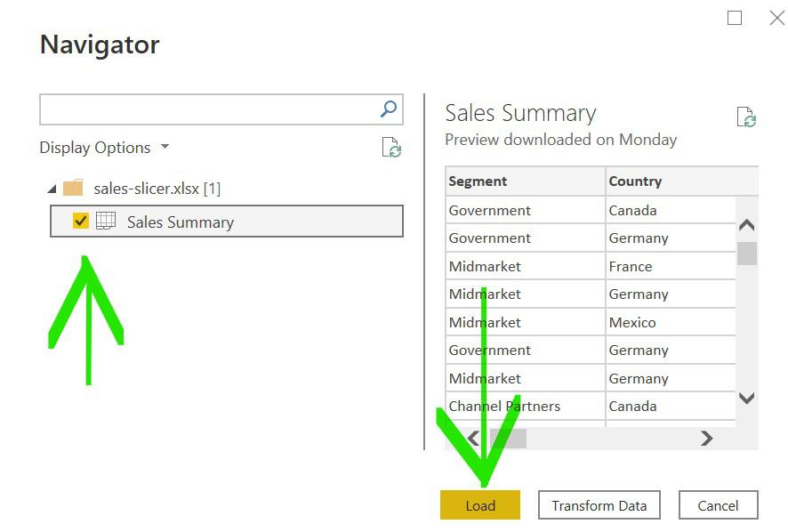

*Loading the dataset*

**Load Bar chart**

Under visualization click on the ‘stacked bar chart’ icon.

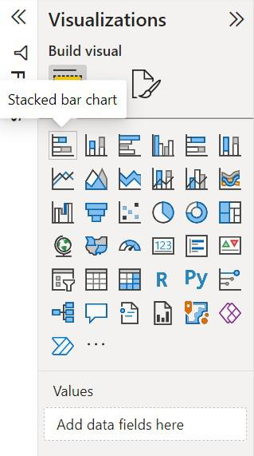

*Selecting the desired chart*

The chart will be loaded on the screen and can be resized if required.

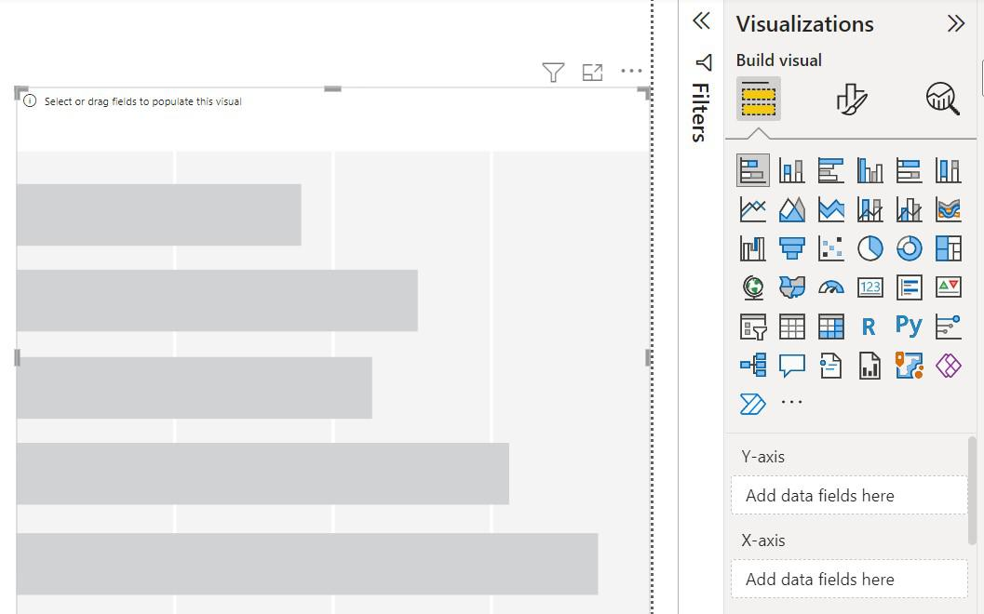

**Creating a sample Chart to demonstrate the creation of a stacked Bar Chart**

To start creating a bar chart click on the fields which is to be used in a bar chart

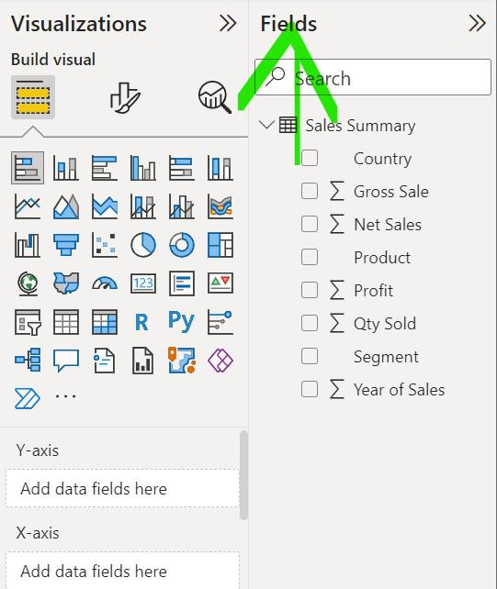

Drag and drops the fields that are to be placed on the X-axis and Y-axis of the chart respectively

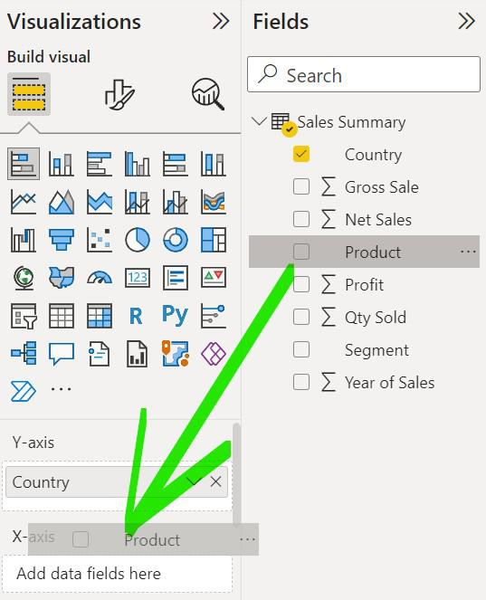

*Selecting the columns for which we want to make a visualization*

A simple Bar chart has been created

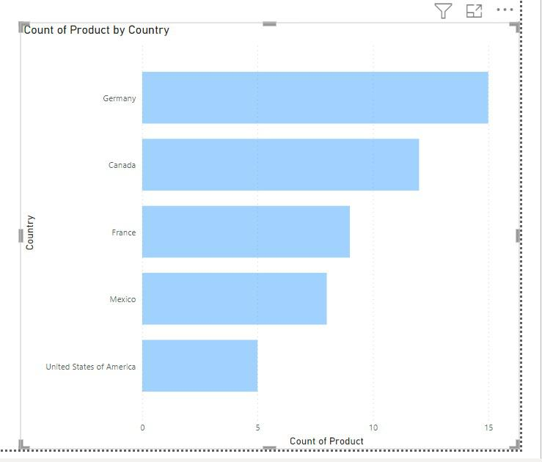

To show the category in different colors use ‘Legend’, drag and drop the category which is to be shown in color

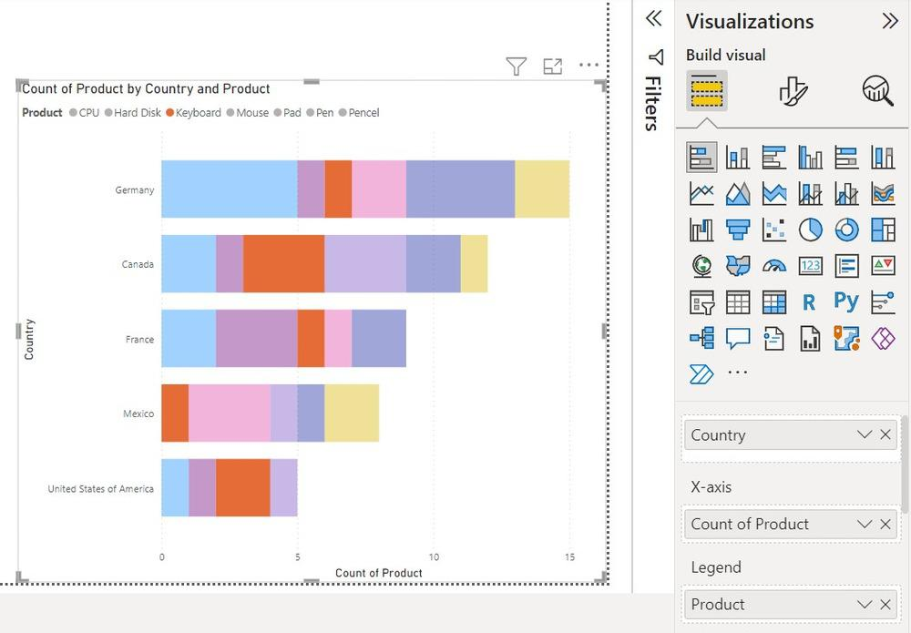

*Stacked Bar Chart for the desired columns of the dataset*

On hovering on certain visuals Little information is shown

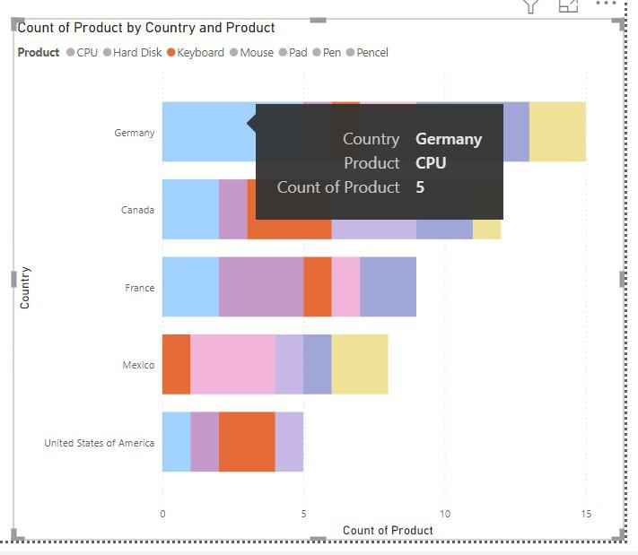

*Tooltips to get info on hovering*

To add more information on the data field drag and drop the category under ‘ToolTips’

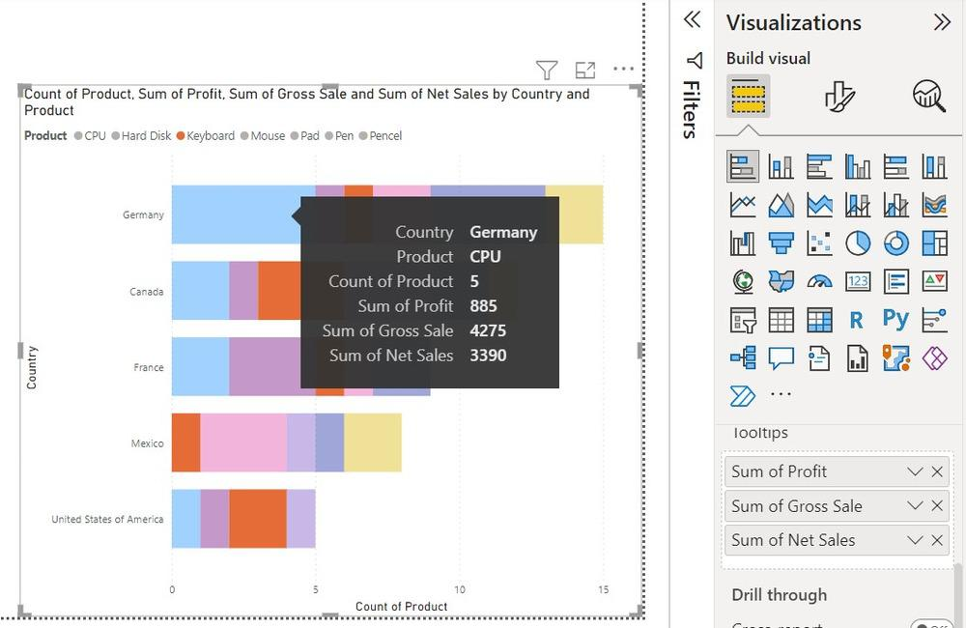

To split the visuals into multiple versions of itself drag the category under ‘Small Multiples’

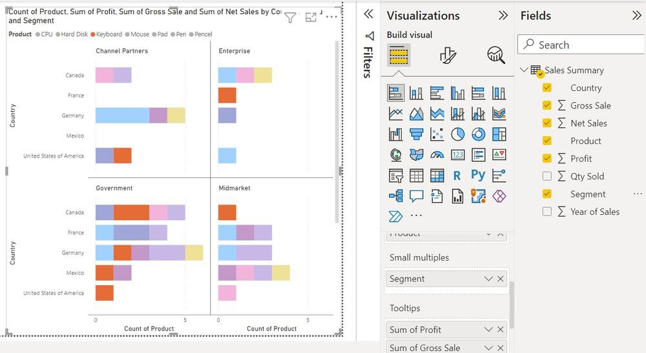

**The disadvantage of using a stacked bar chart**

* Error in estimations can cause false interpretations.
* Bar charts are difficult to read.
* It may confuse if the stack has 4-5 layers.
* They are also difficult to read when there are too many bars.
* **Creating a Dashboard in Power BI**
* One can create its own dashboard from the workspace itself. For example, we have a workspace name, geeks_for_geeks, and we want to create a dashboard, name, **gfg_dashboard.**
* **The following are the  steps:**
* **Step 1:**Go to the required workspace. For example, **geeks_for_geeks**. Click on the **+New** button. A drop-down list appears. Click on the **Dashboard**, to create a new dashboard.
* 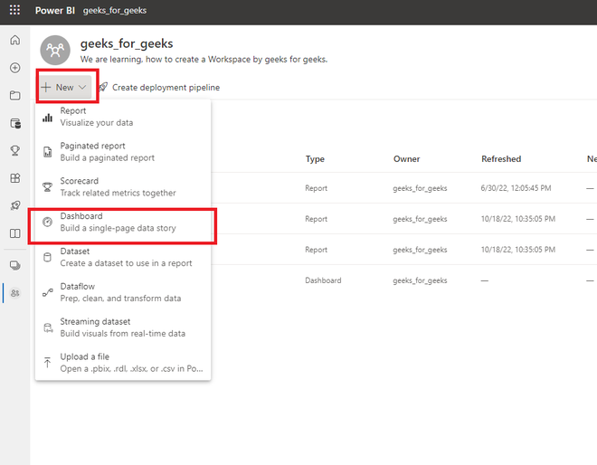
* **Step 2:**A dialogue box name, **Create dashboard**appears. Write the name of the dashboard. For example, **gfg_dashboard**.
* 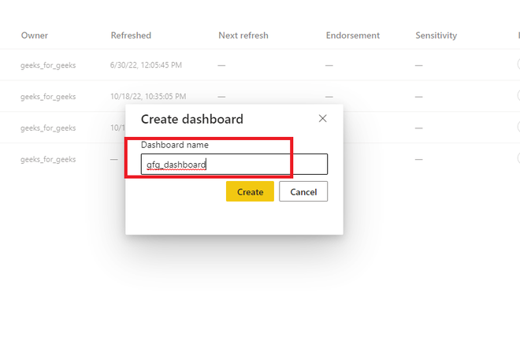
* **Step 3:**An empty dashboard is created.
* 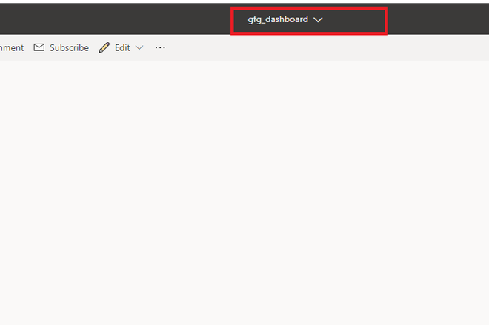
* **Step 4:**One can also view that dashboard is added in the workspace also.
* 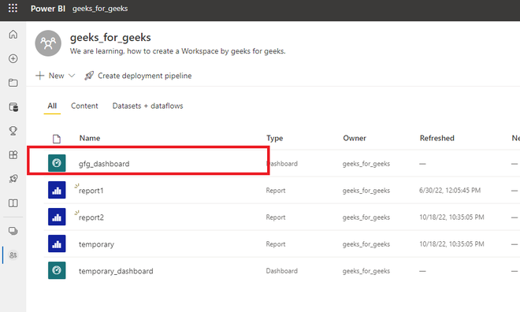
* **Adding a Complete Report to a Dashboard in Power BI**
* As we have created a dashboard successfully. Now, we can add an entire report to the dashboard. For example, you are given a report**report1,**and you want to add this report to a dashboard.
* **Following are the steps:**
* **Step 1:**Go to the required workspace. Click on the report for which you want to pin it to the dashboard. For example, **report1**.
* 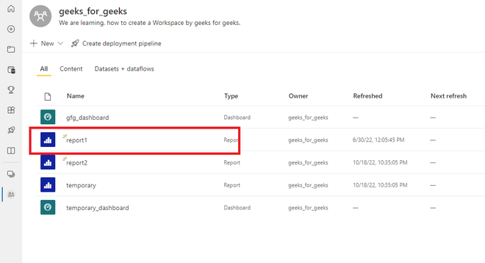
* **Step 2:**In the top navigation bar, we can see **three dots**. Click on it. A drop-down list appears. Click on the **Pin to a dashboard.**
* 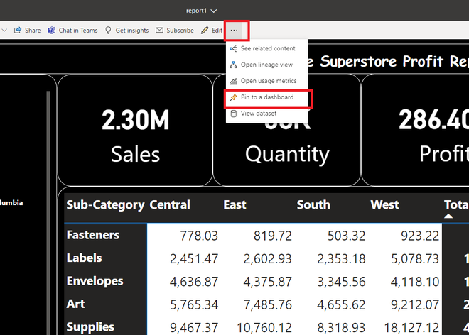
* **Step 3:**A new dialogue box name,**Pin to dashboard** is opened. Click on the **existing dashboard** radio button. Select the dashboard. For example, **gfg_dashboard**. Click on the **Pin live** button.
* 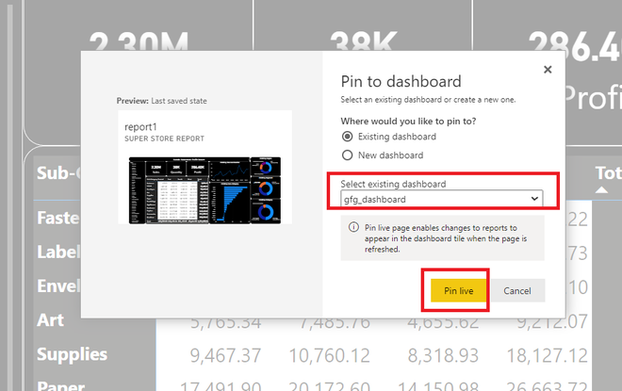
* **Step 4:**On the right side of the page, a new dialogue box name, **Pinned to dashboard**appears. Click on **Go to dashboard**.
* 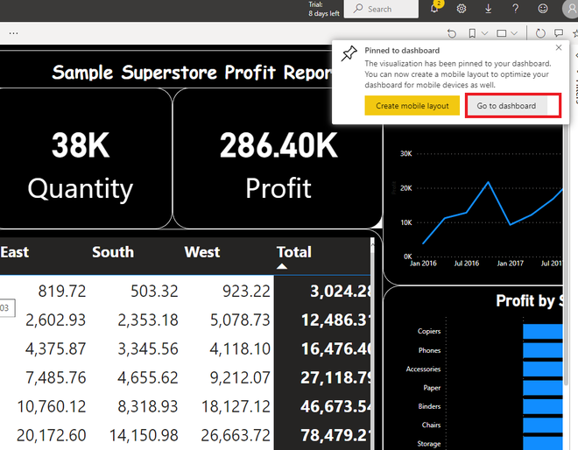
* **Step 5:**An entire report is added, in the **gfg_dashboard**successfully.
* 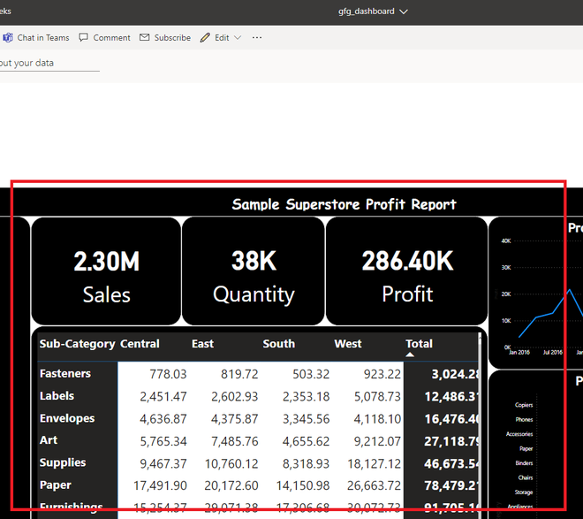
* **Adding components of multiple reports in a dashboard**
* We can also add multiple reports and their components in a single dashboard. For example, if we want to add a **card**from **report1**, and a **graph**from **report2**, in a dashboard name, **gfg_dashboard**.
* **Following are the steps:**
* **Step 1:**Go to the required workspace. Now, we have 2 reports available. Click on the **repor1**.
* 
* **Step 2:**Our, task is to add a card name, **Quantity** to the dashboard. **Hover**on the card. Now, click on the**Pin visual** button.
* 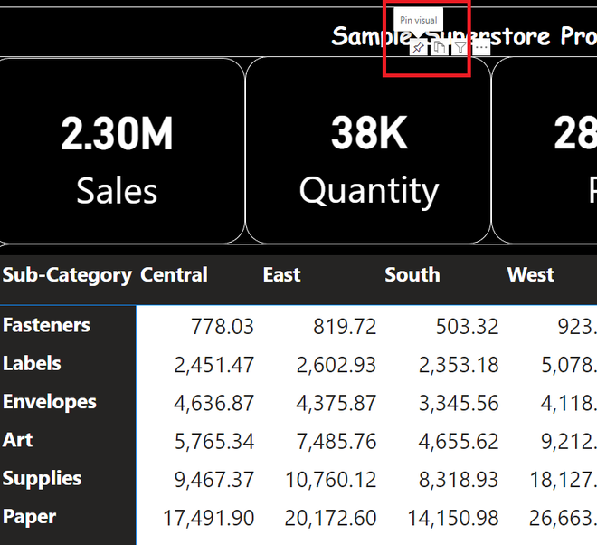
* **Step 3:**A dialogue box name, Pin to dashboard appears. As we want to add this card in **gfg_dashboard**, so click on the **Pin**button.
* 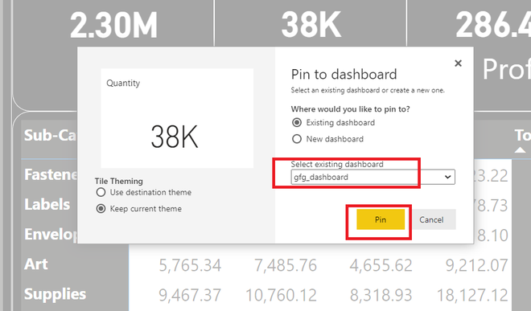
* **Step 4:**A card name, Quantity is successfully added to the dashboard.
* 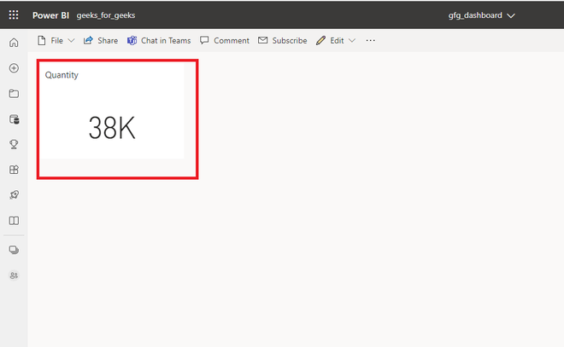
* **Step 5:**Revert back to your workspace. Select **report2**.
* 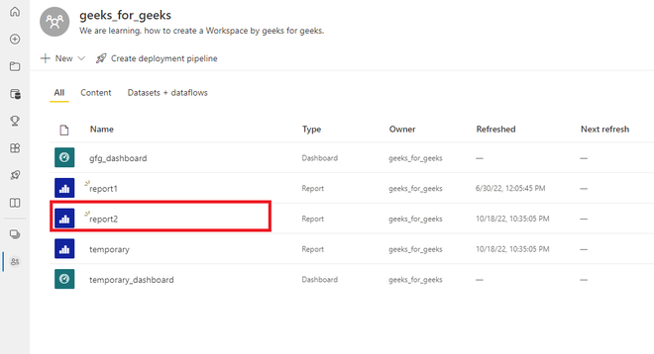
* **Step 6:**Our task is to add, the below-shown graph to our dashboard. **Hover**over the graph. Click on the**Pin visual** button.
* 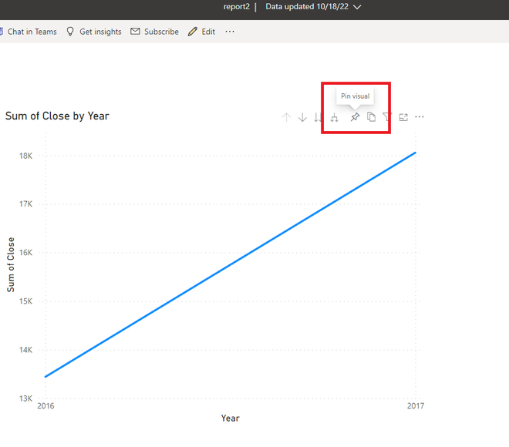
* **Step 7:**A new dialogue box name,**Pin to dashboard** appears. As we want to add this graph in **gfg_dashboard**. Click on the **Pin**button.
* 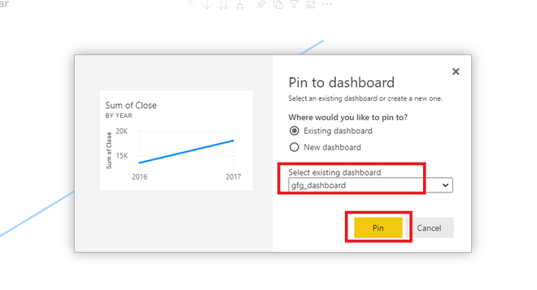
* **Step 8:**A new **graph**is added to the same dashboard. We have successfully added a card and a graph from different reports in a dashboard.
* 